Tab 1

*Chest pain type by Chest pain type*

Chest pai…

1

2

Chest pain type by Exercise angina and Exercise angina

0 | 0

Exercise angina -…

Exercise angina by Chest pain type and Sex

60

47.8%

15.6% 3

4

29.3%

1 | 1

0 200

40

20

400

BP and Max HR by Age

Chest pain type (Sum) 0

Age, Exercise angina

Measures

BP Max HR

Age (Average) Exercise angina (Sum)

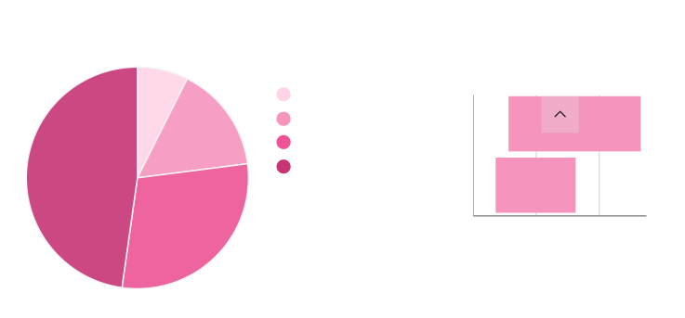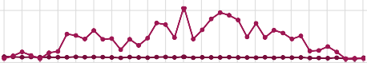

29 35 38 40 42 44 46 48 50 52 54 56 58 60 62 64 66 68 70 74 77 0 100 200 300 400 500 600 700 800 900

Tab 2

Age by Thallium

Thallium

3 7 6

0 1

Cholesterol by Age colored by Sex

Sex

0 1

29 35 38 40 42 44 46 48 50 52 54 56 58 60 62 64 66 68 70 74 77

Age by Chest pain type colored by Sex and sized by Slope of ST

Slope of ST (Sum)

380 480

Sex (Sum)

183 183

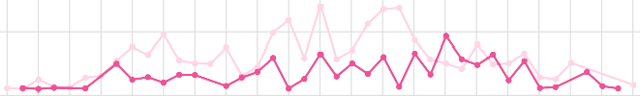

|  |  |  |  |  |  |  |  |  |  |  |  |
| --- | --- | --- | --- | --- | --- | --- | --- | --- | --- | --- | --- |
|  |  |  |  |  |  |  |  |  |  |  |  |
|  |  |  |  |  |  |  |  |  |  |  |  |
|  |  |  |  |  |  |  |  |  |  |  |  |
|  |  |  |  |  |  |  |  |  |  |  |  |

48 49 50 51 52 53 54 55 56 57 58 59 60